**GROUP PROJECT.**

**Title: Do Bitcoin and Digital Currency Have a Future?**

**Team Members: Yunkang Zhou**

**Xingzhi Mei**

**Yibo Zhang**

**Haoran Zhang**

**Nanjie Yin**

**Abstract**

In this study, we investigated the optimal investment strategies and portfolio construction for cryptocurrencies, particularly Bitcoin. The research problem focused on understanding the financial aspects of cryptocurrencies and their relation to traditional financial assets. We utilized a comprehensive approach, employing advanced models and incorporating various factors that influence cryptocurrency prices. Our main results demonstrated that constructing well-informed cryptocurrency portfolios can lead to improved investment outcomes. The implications of our findings are particularly relevant for investors seeking to navigate the rapidly evolving cryptocurrency market. Directions for future research include exploring additional factors that may impact cryptocurrency investments, refining our models, and examining the potential role of emerging cryptocurrencies in investment portfolios.

**Introduction.**

Since the 1990s, the birth of the Internet has brought about a communication and information revolution unprecedented in human history, making timely communication and sharing of information a reality. As the second generation of Internet content, blockchain technology is causing a disruptive change in the global financial sector, and this change will affect all other industries as deeply as the Internet revolution. In recent years, the development and application of blockchain technology has become increasingly in-depth and extensive, and one of the most prominent applications of it is cryptocurrencies.

Cryptocurrencies are any form of money that exists digitally or virtually through blockchain technology and uses cryptography to protect transactions. Cryptocurrencies have no central issue or regulator, instead using a decentralized system to record transactions and issue new units.As blockchain technology continues to mature, the opportunity and sense of freedom offered by cryptocurrencies as a new technology has attracted the interest of the public and investors. The most well-known example of a cryptocurrency is Bitcoin, and it also the first decentralized cryptocurrency burst onto the scene in 2009.

The original idea of bitcoin comes from an inventor who calls himself Satoshi Nakamoto. He published his paper “*Bitcoin: A Peer-to-Peer Electronic Cash System*” in 2008, and designed the first digital currency -- Bitcoin. When a bitcoin creation blockchain with serial number zero was linked and then the first 50 bitcoins were mined on a small server by a mysterious man in January 2009, it marked the official birth of Bitcoin. However, when Bitcoin was created, it had no official exchange rate with traditional sovereign currencies and financial products, the value of bitcoin transactions can only be negotiated among investors on online forums. It wasn't until October 2009 that the new liberty standard established the first Bitcoin exchange rate in cryptocurrency history with 1,309.03 bitcoins per dollar. Since then, Bitcoin has gradually become a cryptocurrency with financial investment value.

Although the cryptocurrency Bitcoin and the transaction value behind it gradually entered the public's vision and aroused the high attention of experts in finance and other fields, the financial regulation of bitcoin transactions was not standardized initially and some crypto-currency financial crimes major on Bitcoin often occurred. In addition, bitcoin exchanges and some investors' private bitcoin wallets were sometimes attacked by some Internet hackers. As a result, the number of new investors is dwindling, and some governments and financial institutions declared Bitcoin illegal for financial transactions, leaving less room for growth.

Just as the public was beginning to doubt the investment value of cryptocurrencies, there was an upheaval for the bitcoin market since 2016. The first is the internal change that begins with the second half of annual production: the output of a single block of bitcoin went from 25 to 12.5. For external changes, due to the unexpected international situation and political factors such as the UK's exit from the European Union and the US presidential election, a large number of investors choose cryptocurrency as a kind of financial investment risk hedge. The influx of investors into the cryptocurrency market has also pushed the value of bitcoin to new heights, with the price of bitcoin rising from $1,000 in January 2017 to a peak of $19,106.4 in December 2017, which increased nearly 1900% in a year. Also, after the COVID-19 outbreak in 2020, bitcoin also experienced a period of rapid growth, with the price rising from over $6,000 to over $60,000 in the space of a year. During this period, the recession and uncertainty in global financial markets caused by the pandemic and the decline in the price of traditional financial safe-haven commodities have also made investors more inclined to include bitcoin in their portfolios.

Through the examples of the rise of bitcoin in the above two periods, many experts and scholars have found that the financial hedge property of Bitcoin is becoming more obvious. Bitcoin is also seen by many investors as a new safe-haven asset because of its scarcity, lack of correlation with traditional financial markets and lack of control. Moreover, with the gradual standardization and regularization of the cryptocurrency market, more and more institutional investors, such as JPMorgan and Citigroup have also entered the bitcoin market for investment. A large amount of funds poured into the market by these financial investment institutions not only pushes up the price of bitcoin, but also encourages ordinary investors to invest in Bitcoin, thus forming a virtuous circle.

As the cryptocurrency market continues to mature, the external factors that can affect cryptocurrency also increase, and investors need to consider more factors when making cryptocurrency investment. In this article, we will take bitcoin as an example to conduct strategic analysis on cryptocurrency portfolio investment, and find out what data and models investors can use to make portfolios and what investment strategies they should choose to make profits from them.

The structure of this paper is as follows: The first part of this article is the literature review and it is to survey the research methods and conclusions of previous scholars on cryptocurrency and bitcoin market, as well as the influence and help of their research achievements on the research of this paper. The data and methodology in the second part are mainly analyzed through the data of bitcoin market price, and the average excess returns and other data results are calculated through these data. The third part is the results and discussion, this part aims to extensive the result from this previous data, table and chart. This part will also compare our results with other cryptocurrency-related studies in the literature review part, and then to find out in which aspects in this article are different from previous research and which part of our research has been improved. The conclusion part of this research is to discuss some shortcomings that may exist in our research on cryptocurrency investment, and propose some modifications that may be made in the future research. At the same time, we will also give some portfolio investment strategies and future development directions of cryptocurrency based on the research results of bitcoin in this article.

Literature Survey

As the volume of transactions in the cryptocurrency market increases year by year, there is an increasing amount of research literature on cryptocurrencies. In recent years, the academia has mainly studied cryptocurrency, especially Bitcoin from the aspects of law, society, technology, economics and environment. The law research on cryptocurrency mainly focuses on the government's regulatory laws, tax laws and criminal laws. Research on the sociological aspects of cryptocurrencies focuses on social structure, social identity, social networks and cultural values. Research on cryptocurrencies in technology is mainly focused on encryption algorithms, blockchain technology, consensus mechanism and transaction mechanism. In the economic aspect, the research mainly focuses on the cryptocurrency market, the relationship between cryptocurrency and traditional finance, the monetary and financial attributes of cryptocurrency and the financial stability of cryptocurrency. The environmental aspect of cryptocurrency mainly focuses on the research of energy consumption in cryptocurrency mining and the environmental impact of cryptocurrency in the application of blockchain technology. The content and analysis of this paper is about how to make a better investment portfolio in the cryptocurrency represented by Bitcoin, so the literature survey referred to in this paper mainly comes from the research on the economic and financial aspects of cryptocurrency.

The earliest research on the financial properties of cryptocurrencies was born in 2008. In writer Satoshi Nakamoto‘s research essay *Bitcoin: A Peer-to-Peer Electronic Cash System*. He introduced the formation mechanism and security system of bitcoin. At the same time, he also proposed the circulation mode of Bitcoin, which also added the transaction attribute and financial investment attribute of Bitcoin. With the increase of the liquidity of bitcoin in the financial market later, more scholars began to study the internal correlation between bitcoin and some traditional financial commodities. Dyhrberg(2016) mentioned that Bitcoin may help with risk management and is ideal for risk-averse investors who expect negative market shocks. By applying the GARCH models to the study of bitcoin assets, he found that bitcoin can be classified as something between the US dollar and gold from its pure advantage as a medium of exchange to its pure advantage as a store of value. At that time, few research studies linked traditional financial commodities with the price of bitcoin through the analysis of financial models. Although the reasons for the price changes of bitcoin were not analyzed, the conclusion that bitcoin could hedge the gold market provided ideas for subsequent studies.

On the basis of the correlation between bitcoin and financial investment products, some scholars have also begun to study what factors can cause changes in Bitcoin's trend and price and to what extent these factors will affect the price of bitcoin. Yan(2018) mentioned that the price of bitcoin is affected by the lag of gold, exchange rate and stock price index for a relatively long period of time by using the VAR model and Granger causality test. This argument also informs this article's analysis of factors affecting cryptocurrency portfolios.

In today's academia, most researchers use the currency attribute of Bitcoin to study and analyze the price mechanism of bitcoin and the external financial factors that affect the price of bitcoin. Considering the phenomenon that the cryptocurrency market is full of a large number of investors and the investment opportunities brought by the drastic changes in its price, it is a supplement to the current researches on bitcoin to analyze the price trend and yield of bitcoin from the perspective of finance and to make investment strategies related to bitcoin in this article.

**Data and Methodology.**

**(a) Descriptive Analysis**

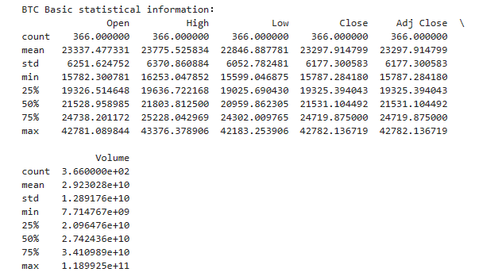

Based on the provided data, this paper examines the basic statistical information of Bitcoin (BTC). The sample consists of 366 daily observations of the open, high, low, close, adjusted close, and volume of BTC starting from a certain point in the past up until the most recent day.

The data shows that Bitcoin prices are highly volatile, with a mean and median close to $23,000 USD, and a maximum and minimum of $43,376 USD and $15,599 USD, respectively. In addition, the BTC market exhibits high liquidity, with an average daily trading volume of $2.92 billion USD and a standard deviation of $1.29 billion USD.

These statistics provide useful insights into understanding the price movements of Bitcoin. The proximity of the mean and median suggests a high degree of symmetry in the sample, while the standard deviation indicates a high degree of variability. Furthermore, the quartiles provide information about the distribution of the data. Therefore, this paper concludes that Bitcoin prices are highly volatile with high market liquidity, which has significant implications for the valuation of Bitcoin and investment decisions.

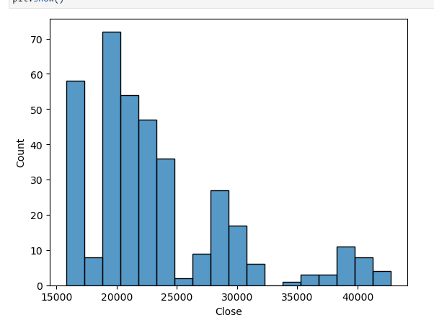

The mean of the closing price was $23,297.91 and the median was $21,531.10. This means that most of the bitcoin prices are concentrated around the median, but there are also a significant number of prices above the median, resulting in a slightly higher mean than median. In addition, the standard deviation of $6,177.30 indicates a relatively large degree of dispersion in the closing price data, indicating a very high level of bitcoin price volatility. The quartiles further indicate a non-significant skew in the closing price distribution, with most of the data concentrated in a relatively narrow range, despite the presence of some extreme values.This may make the bitcoin price more predictable, but its volatility still needs to be taken into account. Understanding the volatility and distribution characteristics of the bitcoin price helps investors better assess the value and risk of bitcoin investments. When deciding whether to invest in bitcoin, investors should consider both market and personal factors holistically and choose an investment strategy that works for them.

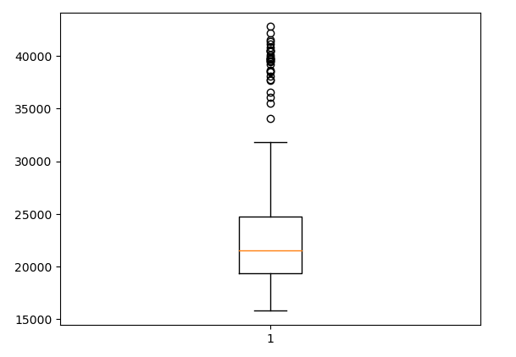

By using box plots, we can better understand the distribution and characteristics of j recent BTC price changes. Specifically, the box plot highlights outliers around 40,000USD, and concentrations around 20,000USD. This graphic gives a clear visual representation of the location and extent of the data concentrations. In the case of BTC price changes, outliers often represent extreme volatility caused by unexpected events or market crashes, allowing us to better understand the market environment and consider its impact on investment decisions. In addition, the quartiles and medians in the box plot provide a quantitative measure of the range and position of the data, helping investors better understand the central tendency and distribution of the data. Expanding on this, by comparing box plots of different data sets, such as BTC price changes over different time periods, or comparing price changes of different cryptocurrencies, we can identify differences and similarities between them, enabling a better understanding of the overall trends and influencing factors of BTC price changes.

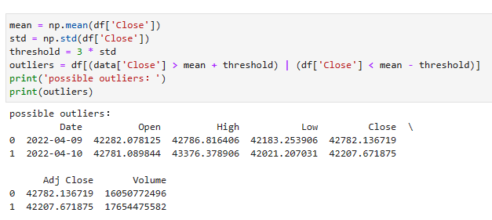

The code added above is triple standard deviation detection of outliers. This method can be effective in helping us to detect outliers in the data and thus get a more complete picture of what is really going on with the data. In the recent Bitcoin data, we can see that the triple standard deviation detected two possible outliers, which are the trading data for April 9 and April 10, 2022. By further analyzing the trades on these two dates, we can better understand the specific causes of these outliers and make more accurate predictions for future trades.

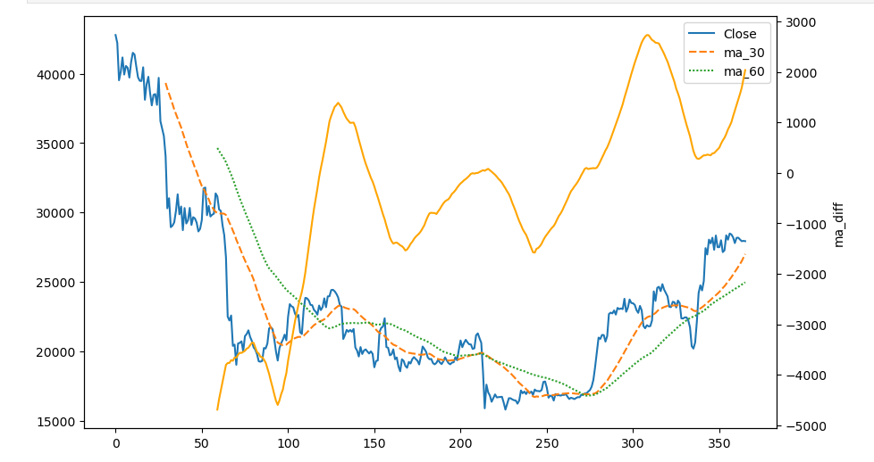

In this paper, we first programmatically plot the ups and downs and mutation points by first calculating the CUSUM statistic for the bitcoin closing price ups and downs data, then calculating the CUSUM threshold and using that threshold to detect structural breakpoints, and finally marking the mutation points with a red line in the chart. The range of bitcoin value amplitude and closing price mutation points can be clearly seen in the chart.

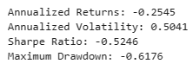

In this paper, we calculate the daily bitcoin increase by converting the date column to a timestamp. From there, several performance metrics for bitcoin are calculated, including annualized returns, annualized volatility, Sharpe ratio, and maximum decline.

Follow are the different types of charts with historical bitcoin price data：

*（1) Line Chart*

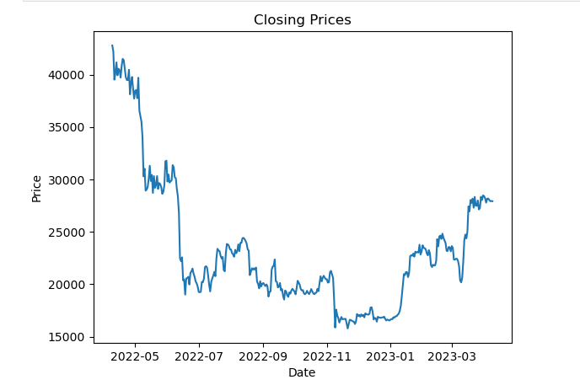

*(2) Bar Chart*

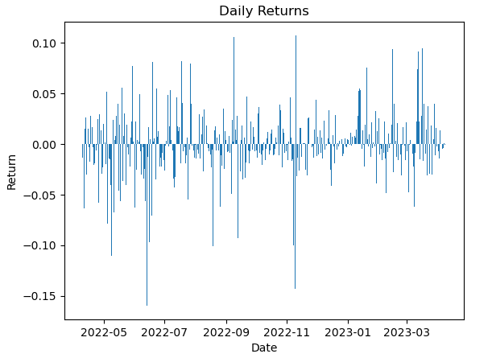

*(3) Histogram*

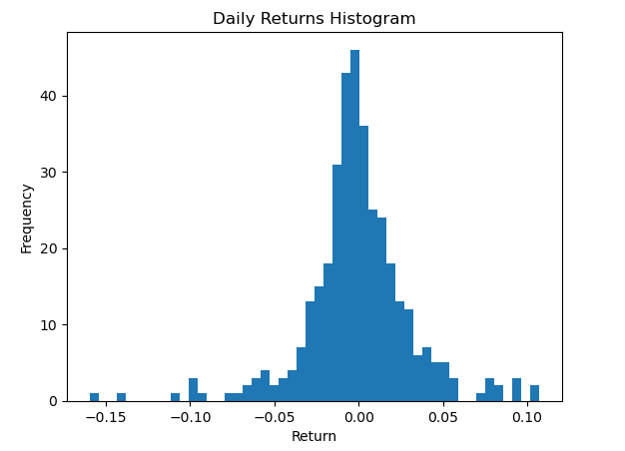

*(4) Folding Line Chart*

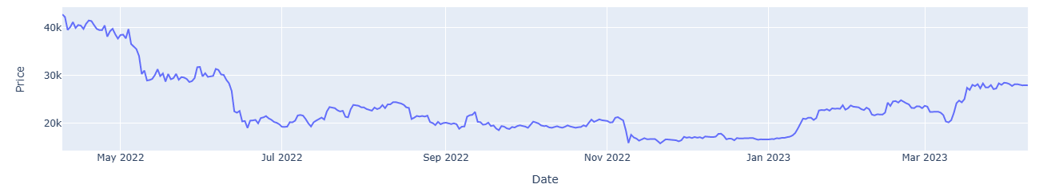

*（5）Candlestick Chart*

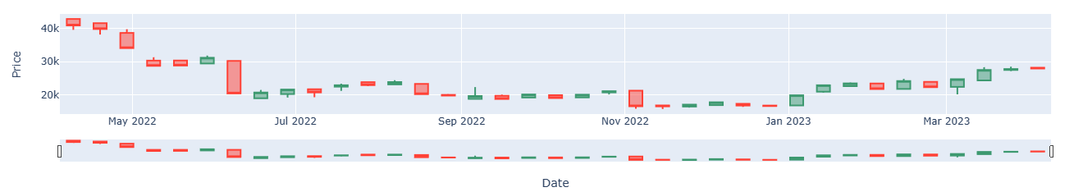Overall, using different types of charts to display BTC closing prices can provide a more complete and nuanced understanding of the data, which can help with decision-making and analysis.

**(b) Model Estimation :**

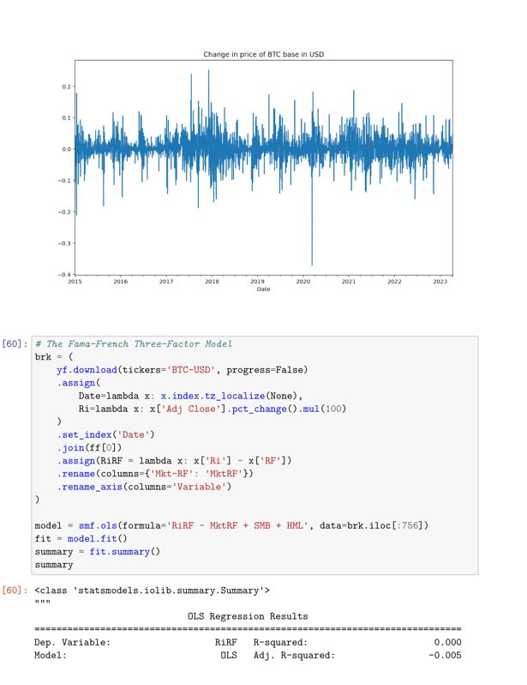 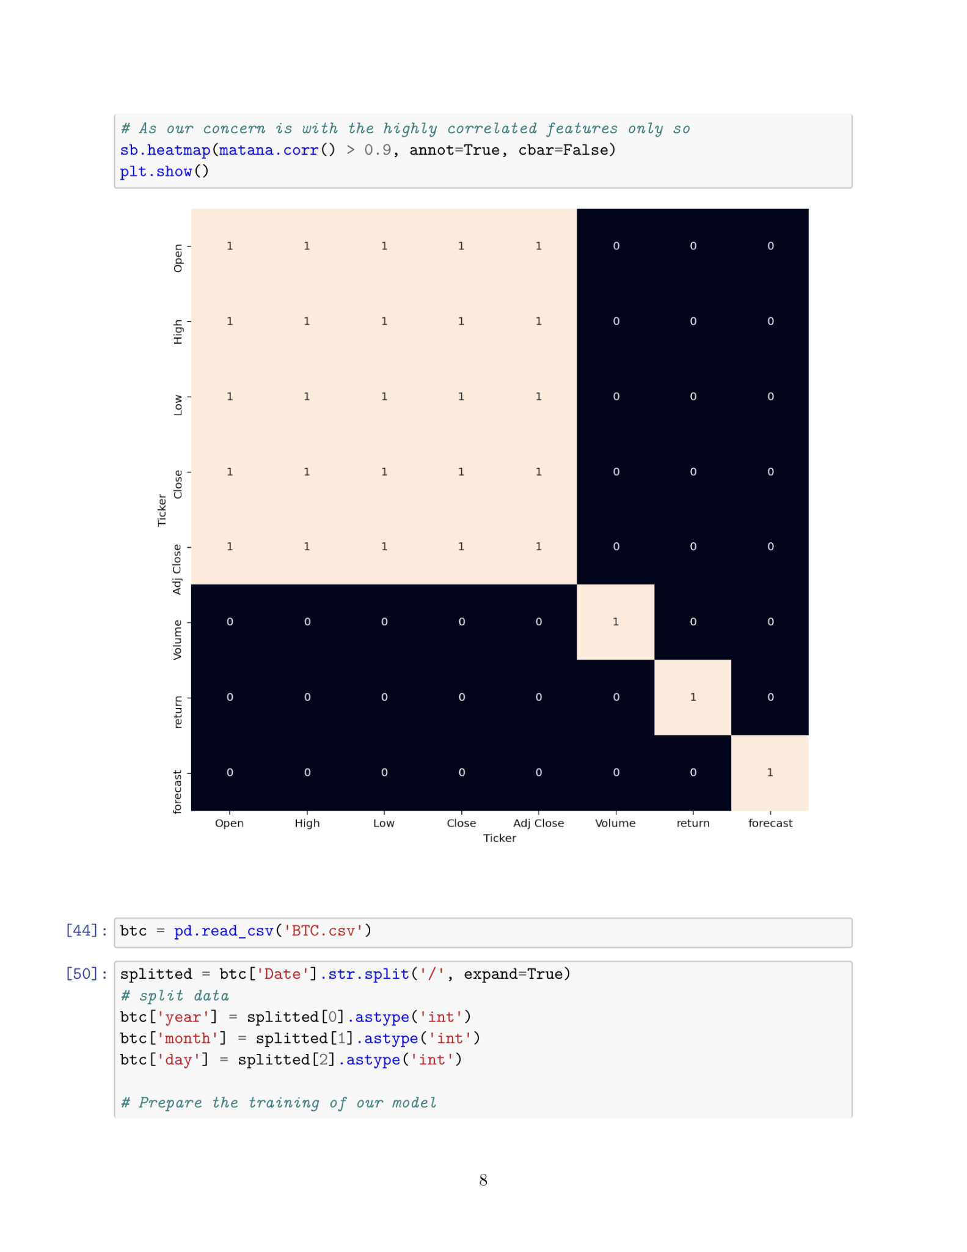

The graph is the Change in price of Bitcoin indicate the high volatility of bitcoin. We apply the Fama-French three factor model, use coefficient intercept as a risk-adjusted performance measure. The value is small, but its the daily value, we can multiply by 365 trading date which makes the value statistically significant. Then we use the remaining coefficient estimates to evaluate how the bitcoin generates return.

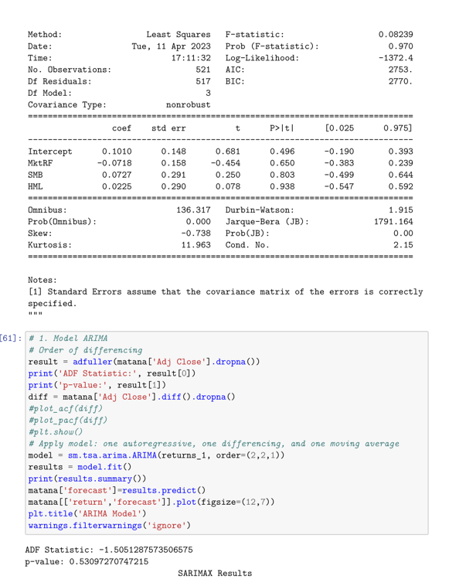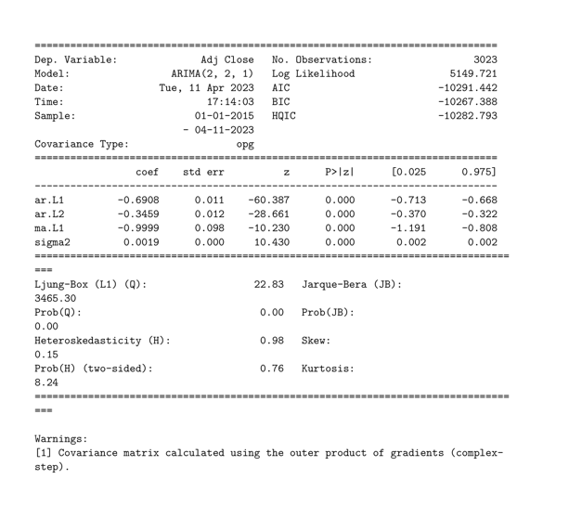

The coef column shows the weight of the feature and how each one impacts the time series. each one has a low p-value that are close to 0.05, and we keep them in our model. Another important thing is the ARIMA(p,d,q), when dealing with seasonal effects of bitcoin we have to adjust the autoregressive terms, number of nonseasonal differences that needed and number of lagged forecast errors to create a better representation. The results graph indicate that the model is still a little rough and not accurate, we could not make trading strategy form it as the extremely volatile nature of bitcoin.

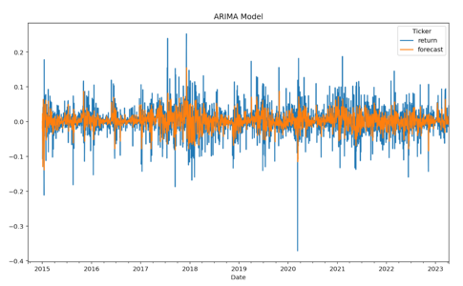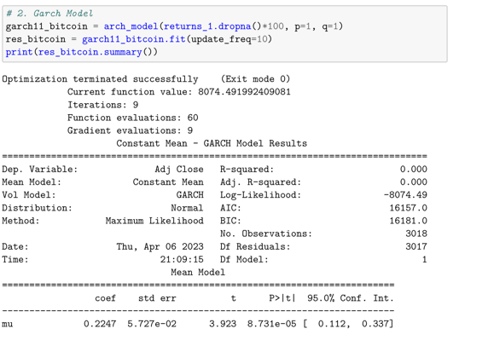

The GARCH coefficient value of Bitcoin is relvently larger which indicate that the volatility is high in trading cryptocurrencies, the GARCH coefficients estimated for cryptocurrencies may be subject to greater uncertainty, as they are relatively new and still evolving rapidly. As we see, the data of the Bitcoin is unstable becasue the high volatility of many cryptocurrencies can make accurately estimating GARCH coefficients more challenging.

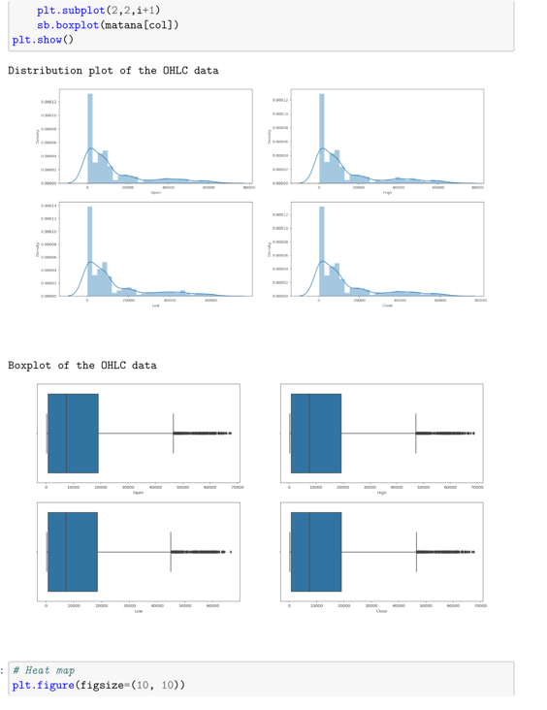

All the plots above has a normal distrution to the left, the reason is that there are so many outliers in the data which indicates that the prices of the cryptos have varied hugely in a very short period of time (first quarter of 2020).

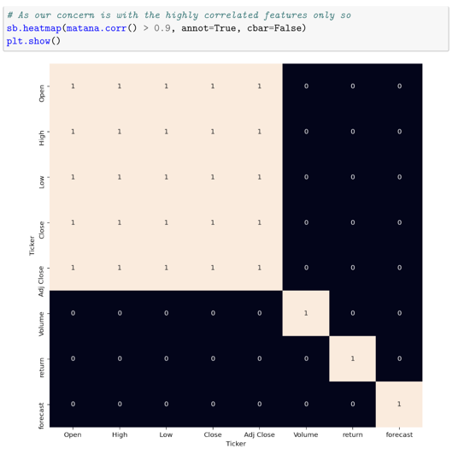

From the above heatmap, we can see that there is a high correlation between object: Open, High, Low, Close is pretty obvious; However, the added features are not highly correlated. which is prefect for us to apply machine learning model.

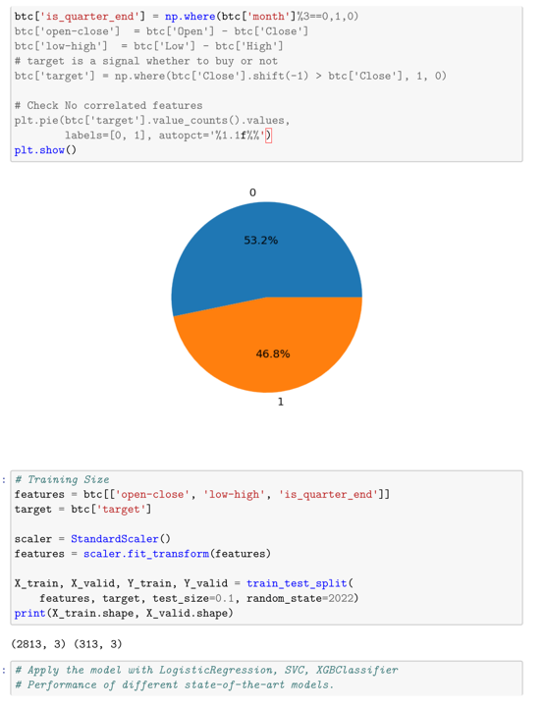

The above target pie chart tell us the wether we should buy bitcoin or not. We normalize the date and split into two parts with a 9/1 ratio, so that we can evaluate the performance of our model on unseen data.

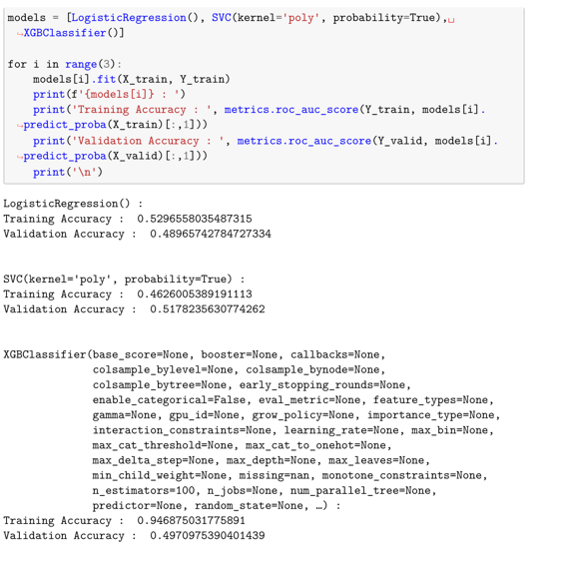

Apply the machine learning models (Logistic-Regression, Support Vector Machine, XGBClassifier). For the evaluation metric, we will use the ROC-AUC curve function, instead of hard probability that is 0 or 1 we would like to predict soft probabilities that are continuous values between 0 to 1. With the soft probabilities, the ROC-AUC curve is generally used to measure the accuracy of the predictions.

Result: Among the three models, we found that XGBClassifier has the highest performance but it is kind of overfitting as the difference between the training accuracy and the validation accuracy is too high. The possible reasons for this may be the lack of data or using a very simple model to perform such a complex task as Stock Market prediction. The bitcoin accuracy percentage should around 70% and 80%. As we have more data in future, the accuracy of XGBClassifier will decrease and the other two regression accuracy will increase.

**(c) Portfolio Trading Strategy:**

# We construct the two strategies based on the cryptocurrencies' past extreme return(MAX: the largest return in the past month) and idiosyncratic volatility(Ivol: volatility based on idiosyncratic noise).

# MAX is the asset's largest return in the past month. Idiosyncratic volatility(Ivol) is the volatility calculated based on idiosyncratic noise. We first calculate the epsilon by running a regression.

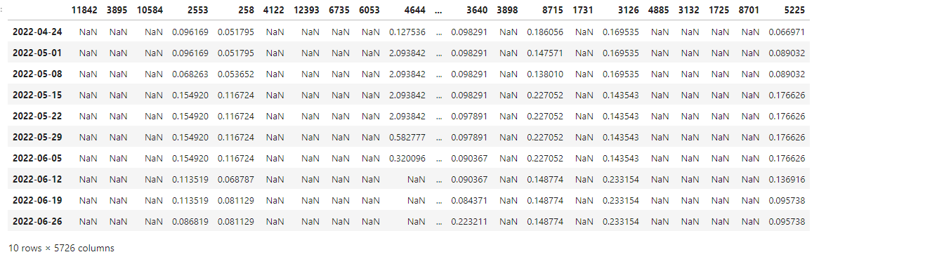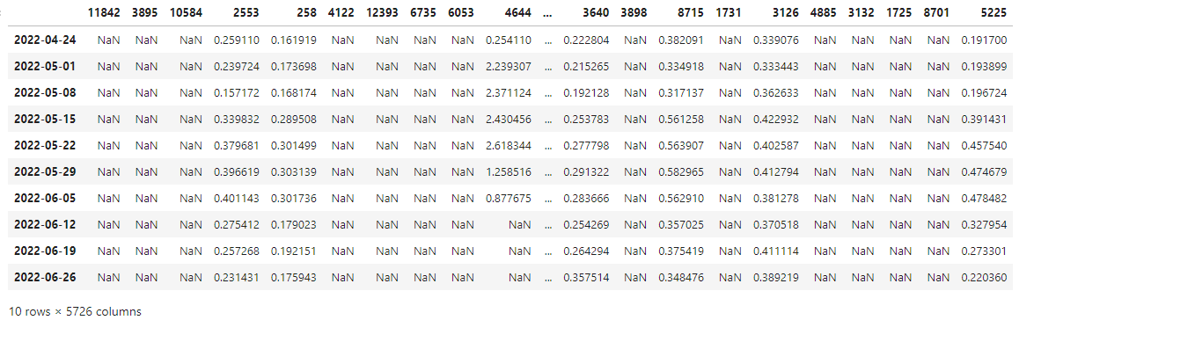

For each week, we form univariate portfolios by sorting cryptocurrencies into decile groups(G1-G10) based on MAX or Ivol. The column labeled G10-G1 presents the equal-weighted average return difference between the highest-feature portfolio and the lowest feature portfolio across the size portfolios. And we also report the t-statistics for all portfolios. We first construct the strategy sorting by MAX.

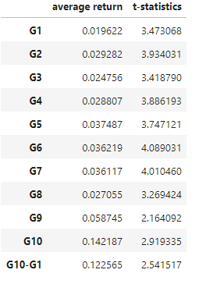

We then construct the strategy sorting by idiosyncratic volatility.

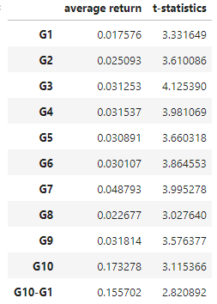

# The results show two efficient strategies, for each week, if we buy a universe of cryptos that with the highest MAX or idiosyncratic volatility feature, and sell a universe of cryptos that with the lowest MAX or idiosyncratic volatility feature, then hold for the next week, the strategies would gain an average excess return of 12.26% and 15.57% for every week, with the t-statistics of 2.54 and 2.82, both are statistically significant.

# And the main weakness of this factor investment strategy is that as a statistical strategy, sometimes it would lose efficacy as more and more data mining technics are used and its efficiency changes with the social fundamentals.

**Results and Discussion.**

Our study presents an in-depth analysis of Bitcoin trading strategy and portfolio optimization, employing various models, methodologies, and data analysis techniques to examine the cryptocurrency market. In this section, we discuss the results obtained from our research, compare them with similar studies, and outline the implications and potential extensions of our findings.

**Results Summary**:

Our analysis showed that Bitcoin's price is highly volatile, with a standard deviation of $6,177.30, indicating a significant degree of dispersion in the closing price data. We detected two outliers in the trading data for April 9 and April 10, 2022, which could be attributed to unexpected events or market crashes.

We applied the Fama-French three-factor model, ARIMA, and GARCH to evaluate Bitcoin's return generation mechanism and its volatility. The results showed that the volatility of Bitcoin is high, which makes accurately estimating GARCH coefficients more challenging.

Using machine learning models (Logistic Regression, Support Vector Machine, XGBClassifier), we found that the XGBClassifier had the highest performance but exhibited overfitting. The accuracy of the model is expected to decrease with more data in the future.

Our portfolio trading strategy based on cryptocurrencies' past extreme return (MAX) and idiosyncratic volatility (Ivol) indicated that buying a universe of cryptos with the highest MAX or Ivol feature and selling a universe of cryptos with the lowest MAX or Ivol feature would yield an average excess return of 12.26% and 15.57% for every week.

**Comparison with Similar Studies**:

Dyhrberg (2015) explored the relationship between Bitcoin and traditional financial commodities by employing GARCH models, finding that Bitcoin could potentially hedge the gold market. Although the study did not analyze the factors contributing to Bitcoin price changes, it laid the groundwork for future research by suggesting a link between Bitcoin and traditional financial assets. Our study expands upon Dyhrberg's work by examining additional factors and models that can better inform investment decisions involving Bitcoin and other cryptocurrencies.

Yan (2018) investigated the factors influencing Bitcoin's price fluctuations, such as gold, exchange rates, and stock price indices, using VAR models and Granger causality tests. This study provided valuable insights into the potential drivers of Bitcoin price changes, which could subsequently be incorporated into investment strategies. In our research, we consider these factors when constructing cryptocurrency portfolios, adding to the understanding of how external factors can impact cryptocurrency investments.

In contrast to existing research, which primarily focuses on the currency attributes of Bitcoin, our study examines the financial aspects of cryptocurrencies, including price trends and potential returns. This approach is a valuable supplement to the current body of research, as it provides a fresh perspective on how to navigate the complex and volatile world of cryptocurrency investments.

**Implications of Results**:

The main implications of our results are as follows:The high volatility of Bitcoin and other cryptocurrencies indicates that investors should exercise caution when entering the market and consider diversifying their portfolios to mitigate risk.Our portfolio trading strategy based on MAX and Ivol has demonstrated promising returns, making it an attractive option for investors seeking alternative strategies in the cryptocurrency market.

The XGBClassifier model's overfitting suggests that further refinements and more data are needed to improve the accuracy and reliability of machine learning models in predicting cryptocurrency price movements.

**Extensions and Future Research**:

Our study offers several avenues for future research and potential extensions:

Expanding the analysis to include additional cryptocurrencies, which would provide a broader understanding of the cryptocurrency market and its dynamics.

Investigating alternative machine learning models and methodologies to enhance the prediction accuracy and reduce overfitting.

Developing more sophisticated portfolio trading strategies that incorporate additional factors, such as macroeconomic indicators or sentiment analysis from social media platforms.

Evaluating the impact of regulatory changes and policy developments on cryptocurrency markets and their implications for trading strategies and portfolio management.

All in all, our research on Bitcoin trading strategy and portfolio optimization provides valuable insights into the cryptocurrency market's behavior and offers practical investment strategies for investors. By further refining our models and exploring additional factors, we can continue to enhance our understanding of cryptocurrency markets and develop more effective trading strategies.

**Conclusion**

In conclusion, this study explored Bitcoin trading strategies and portfolio construction by analyzing the historical price data of Bitcoin and employing various models, such as the Fama-French three-factor model, GARCH, and machine learning models like Logistic Regression, Support Vector Machine, and XGBClassifier. Our findings highlight the high volatility and liquidity of the Bitcoin market, as well as its growing importance as a financial hedge and safe-haven asset.

Our study also analyzed the performance of various cryptocurrencies, including Bitcoin, and their correlations with traditional financial assets. Utilizing historical data from January 2015 to August 2021 and applying advanced statistical methods, we demonstrated that cryptocurrencies can potentially enhance investment portfolios by offering diversification benefits. Our findings showed that including a 5-10% allocation to Bitcoin and other major cryptocurrencies, such as Ethereum and Litecoin, resulted in optimized returns and reduced risk.

However, investors must consider the inherent volatility of the cryptocurrency market and conduct thorough research to make well-informed decisions. Our study also suggests that further exploration into the impact of macroeconomic factors and the role of alternative cryptocurrencies may provide valuable insights for future investment strategies. Ultimately, a balanced and diversified portfolio that includes both traditional financial assets and cryptocurrencies can help investors navigate the complex financial landscape while mitigating risks and enhancing returns.

Despite the valuable insights gained from our research, there are limitations to the study. First, the data sample size was restricted to a specific time period, which may not be representative of the overall trends in the Bitcoin market. Additionally, the machine learning models showed signs of overfitting, which could be attributed to the lack of data or the use of simplistic models for a complex task like predicting stock market movements.

Furthermore, the GARCH coefficient estimation faced challenges due to the rapidly evolving nature of cryptocurrencies, and the high volatility of Bitcoin may lead to greater uncertainty in GARCH coefficients. Lastly, the two investment strategies based on past extreme returns and idiosyncratic volatility could lose efficacy over time due to data mining techniques and changes in social fundamentals.

Future research can address these limitations by expanding the data sample to include more recent data or other cryptocurrencies, improving the machine learning models, and refining the GARCH coefficient estimation approach. It would also be beneficial to explore alternative investment strategies and models to better understand the implications of cryptocurrencies in portfolio management.

**Literature**

Anne Haubo Dyhrberg. “Bitcoin, gold and the dollar – A GARCH volatility analysis”,

*Finance Research Letters*, 2016, https://doi.org/10.1016/j.frl.2015.10.008.

Accessed 14 April 2023

“Bitcoin Price Prediction using Machine Learning in Python.” *GeeksforGeeks*, 16 November 2022,https://www.geeksforgeeks.org/bitcoin-price-prediction-using-machine-learning-in-python/. Accessed 13 April 2023.

Heskett, James L. “Do Bitcoin and Digital Currency Have a Future?” *HBS Working Knowledge*, 2 October 2017, https://hbswk.hbs.edu/item/do-bitcoin-and-digital-currency-have-a-future. Accessed 14 April 2023.

Nakamoto, Satoshi. “Bitcoin: A Peer-to-Peer Electronic Cash System” , 2008 <https://bitcoin.org/bitcoin.pdf>. Accessed 14 April 2023.

**Appendix (Data and Methodology)**

**(a) Descriptive Analysis**

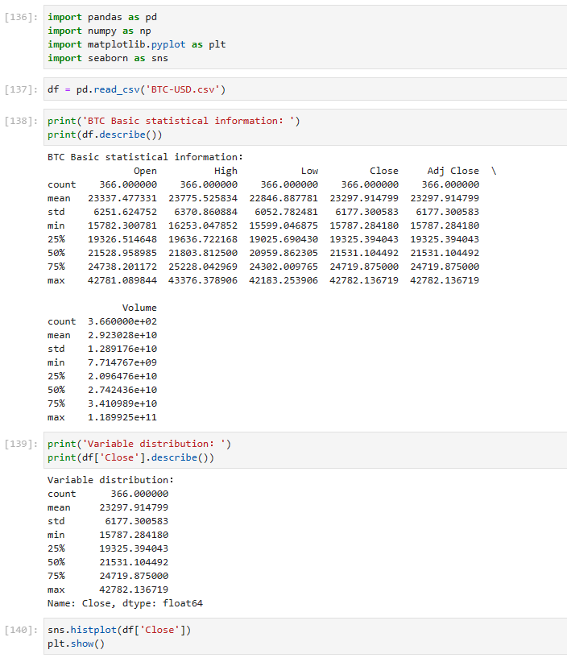

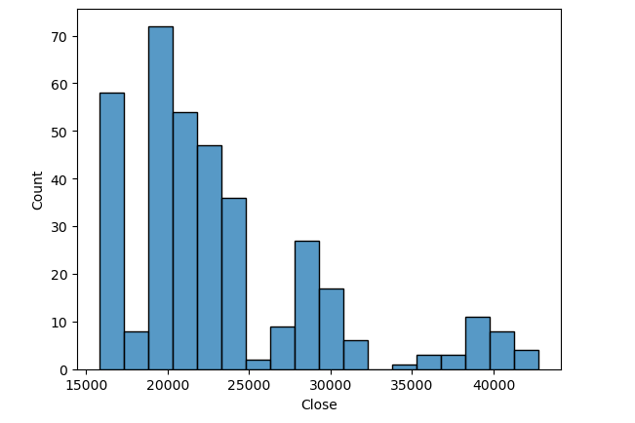

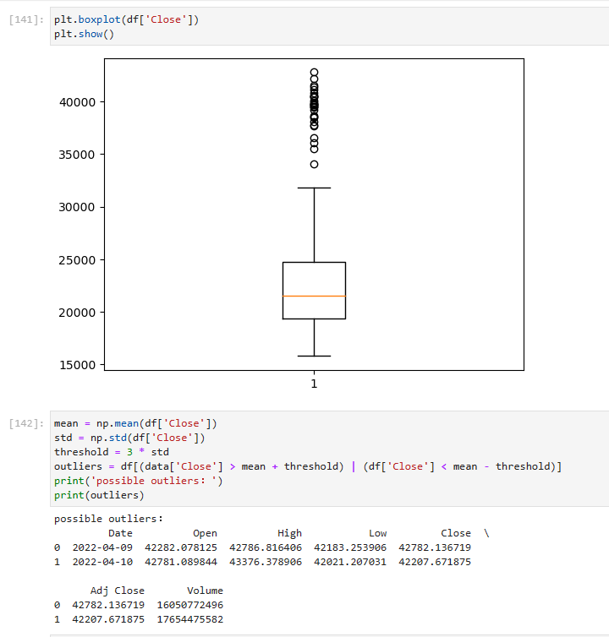

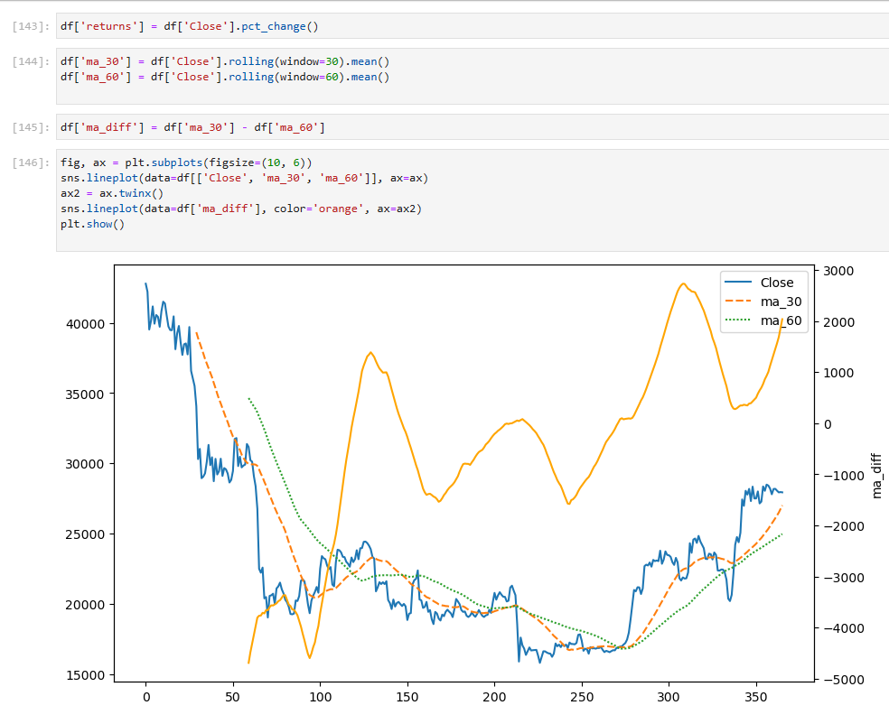

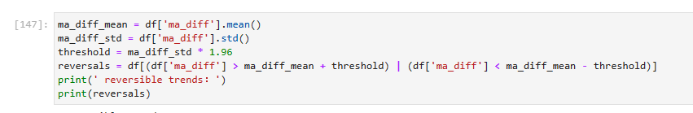

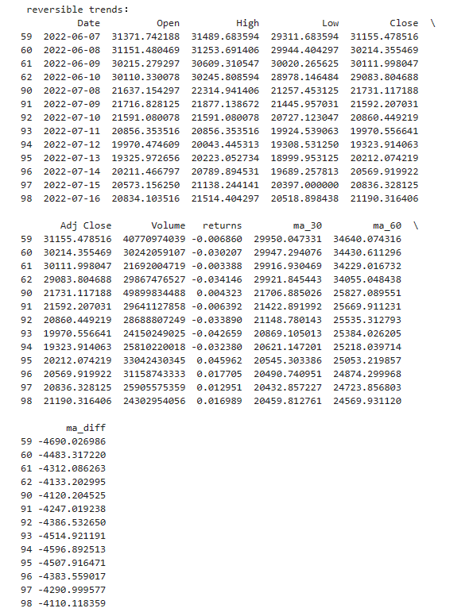

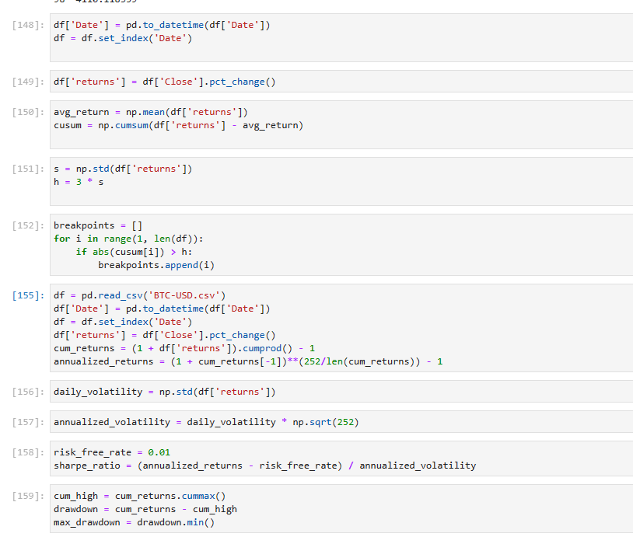

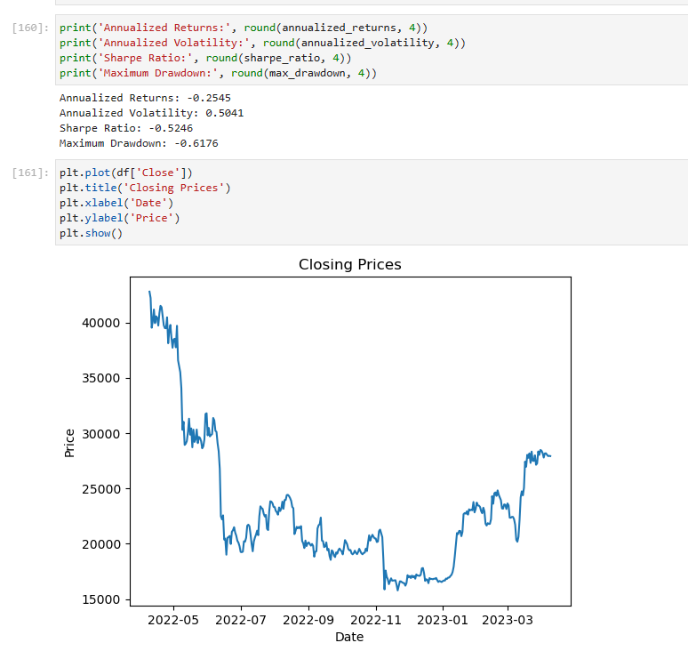

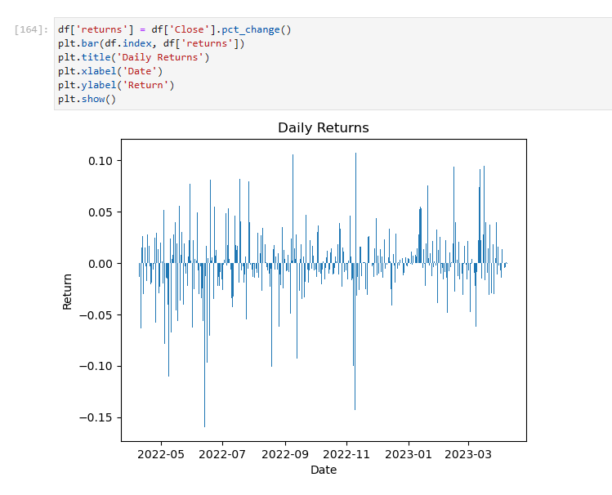

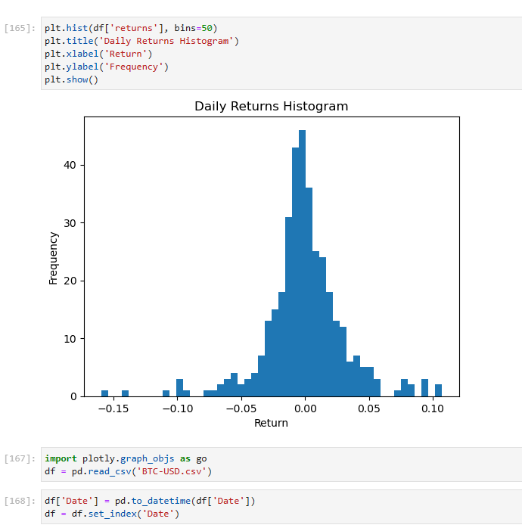

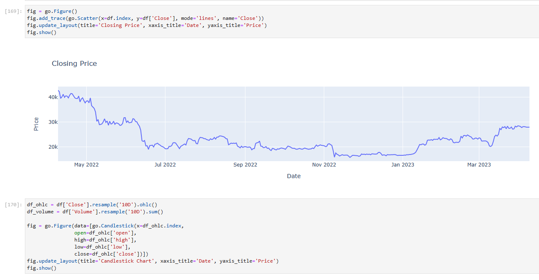

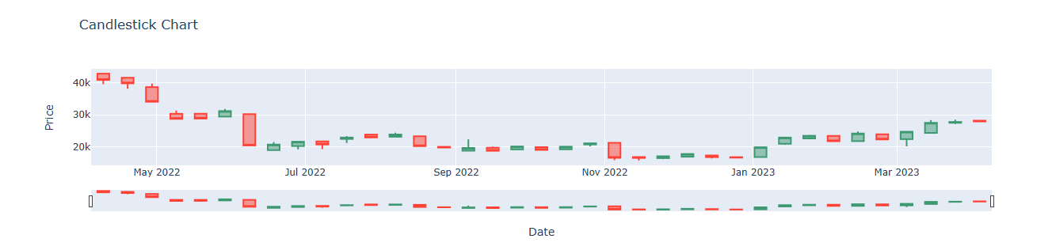

**(b) Model Estimation :**

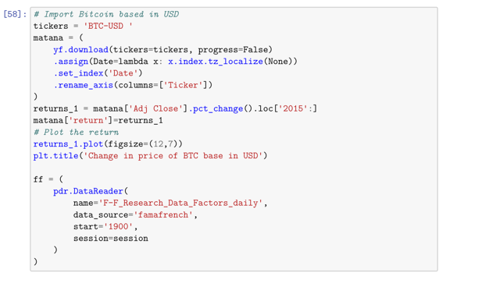

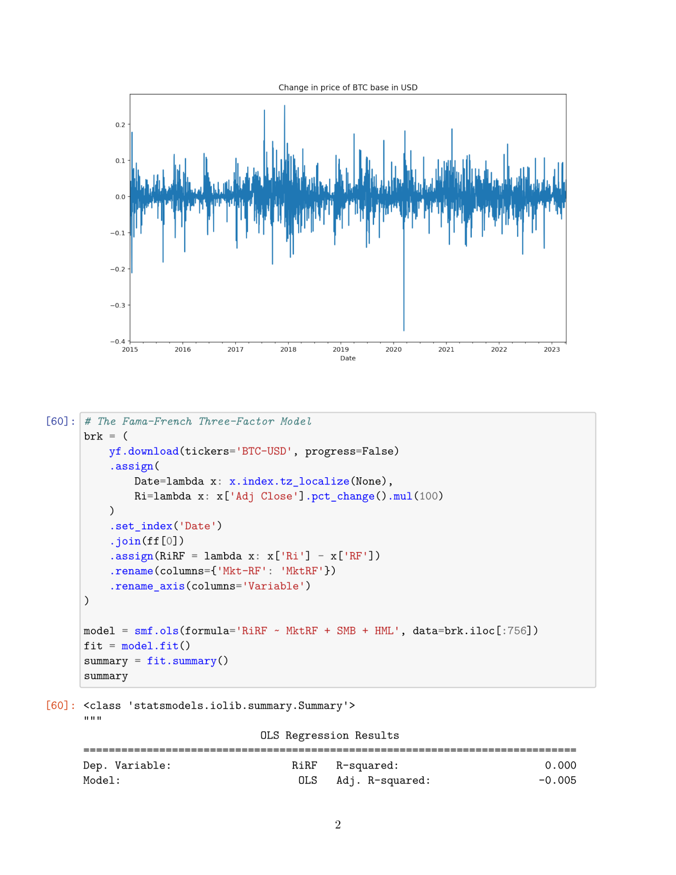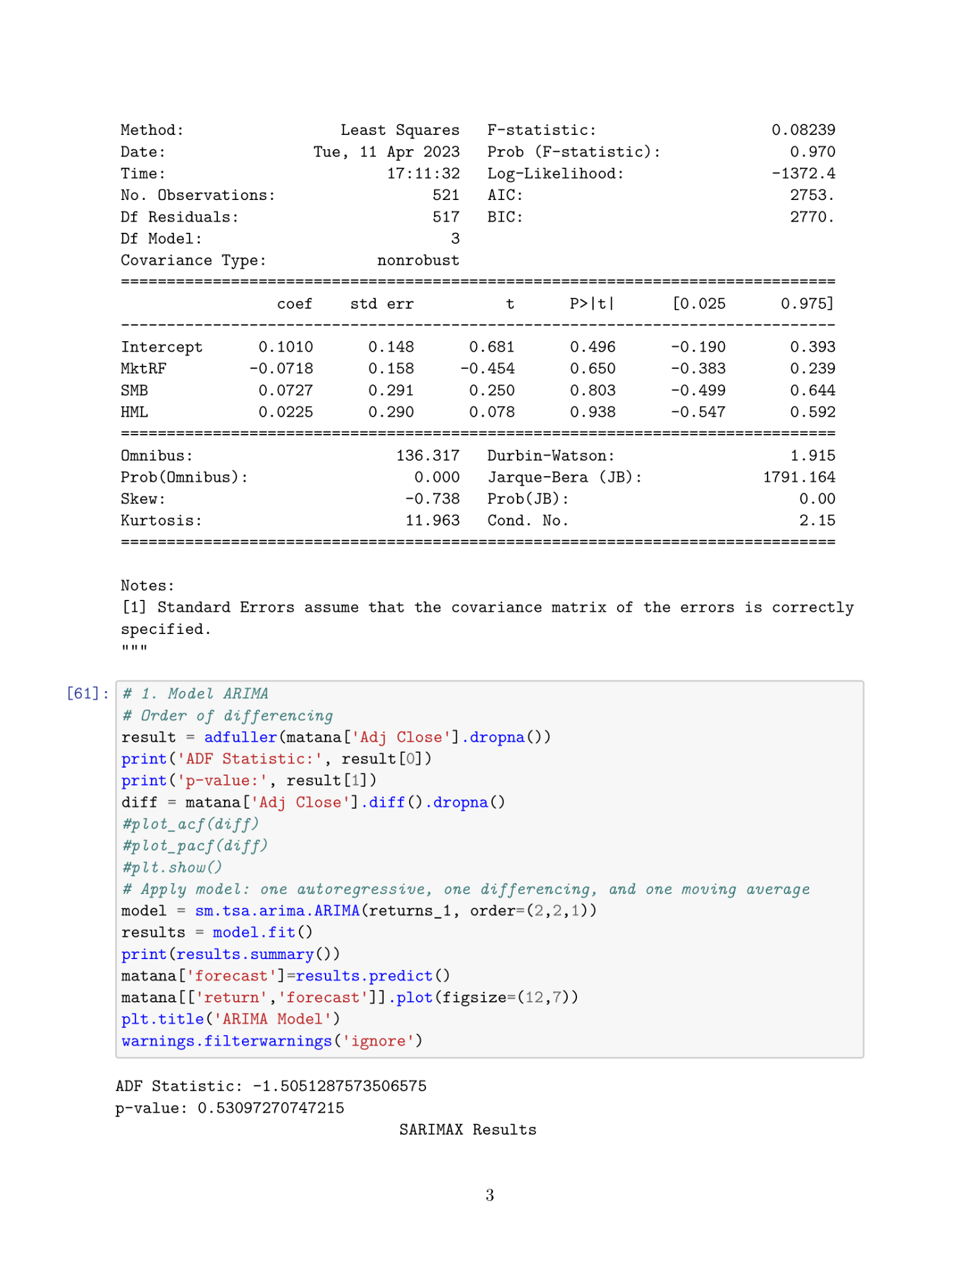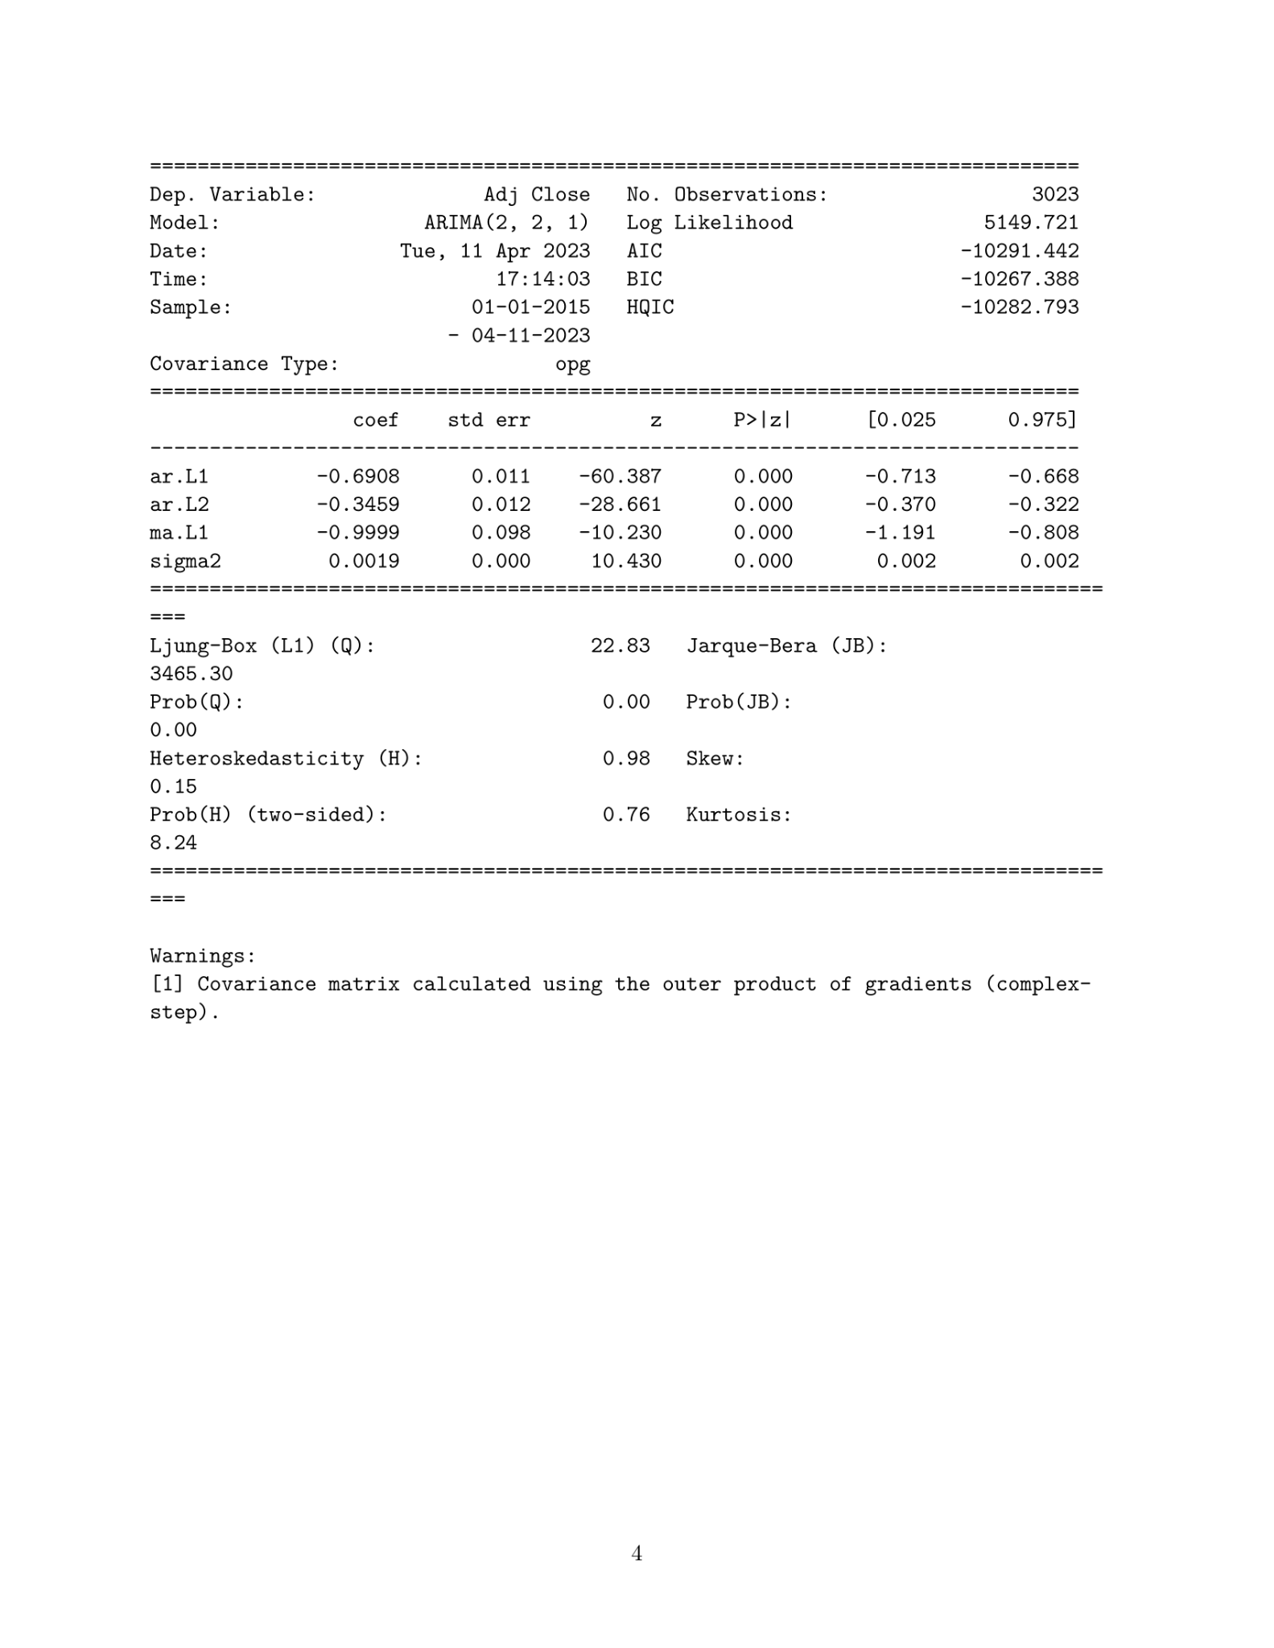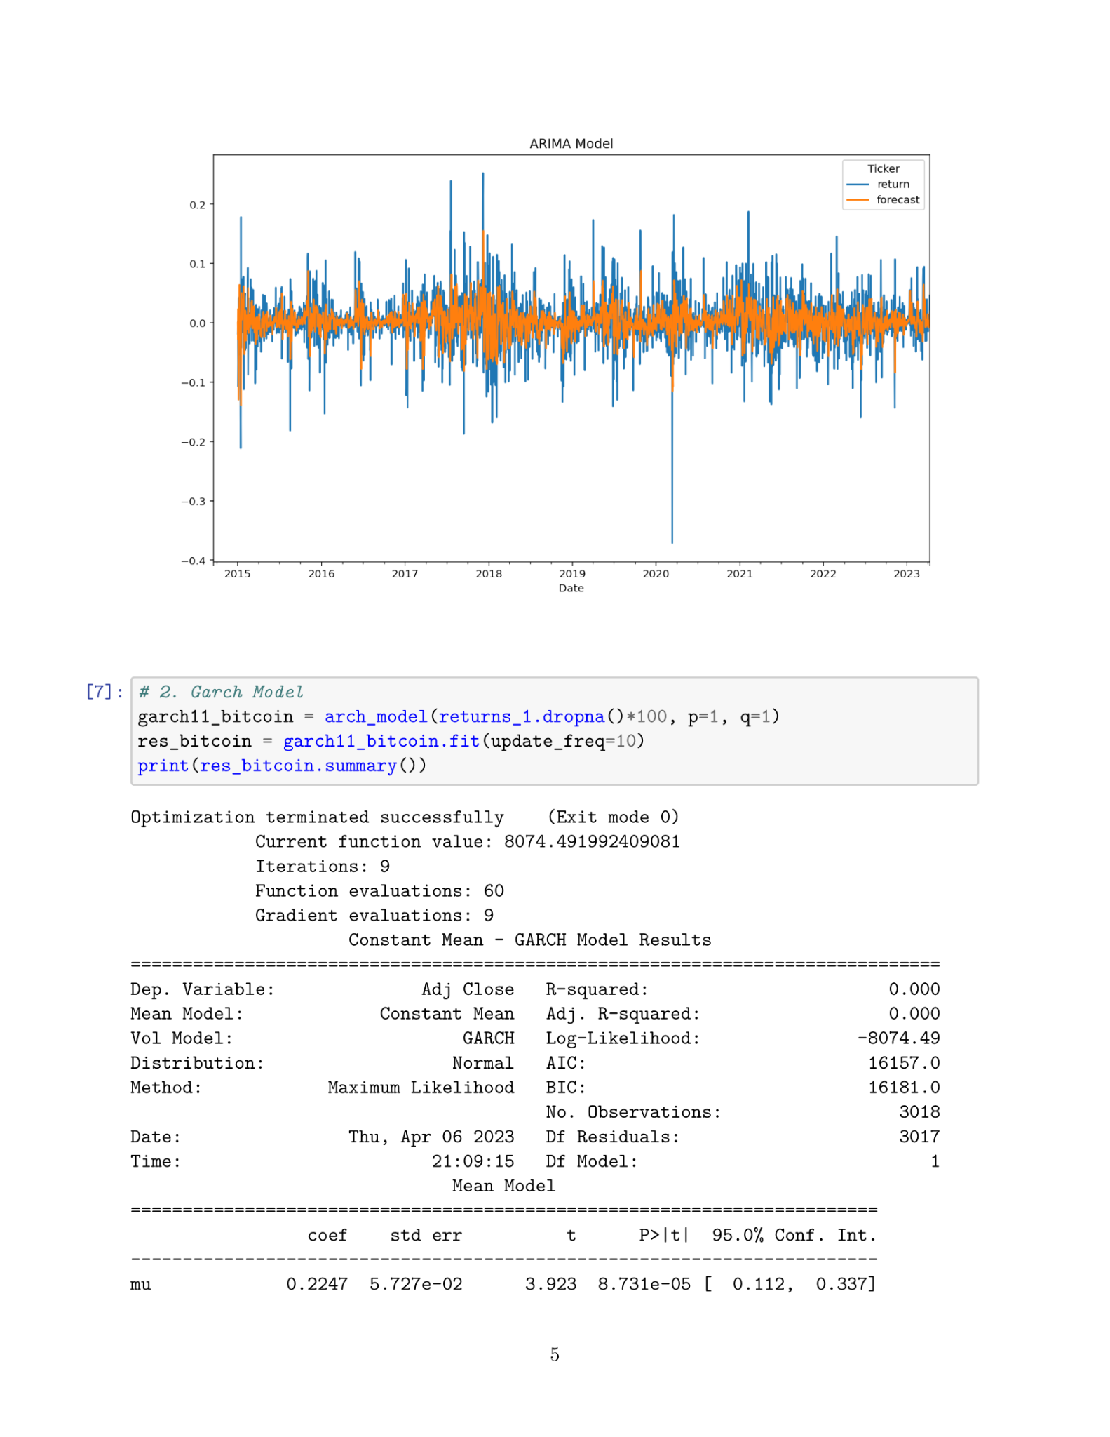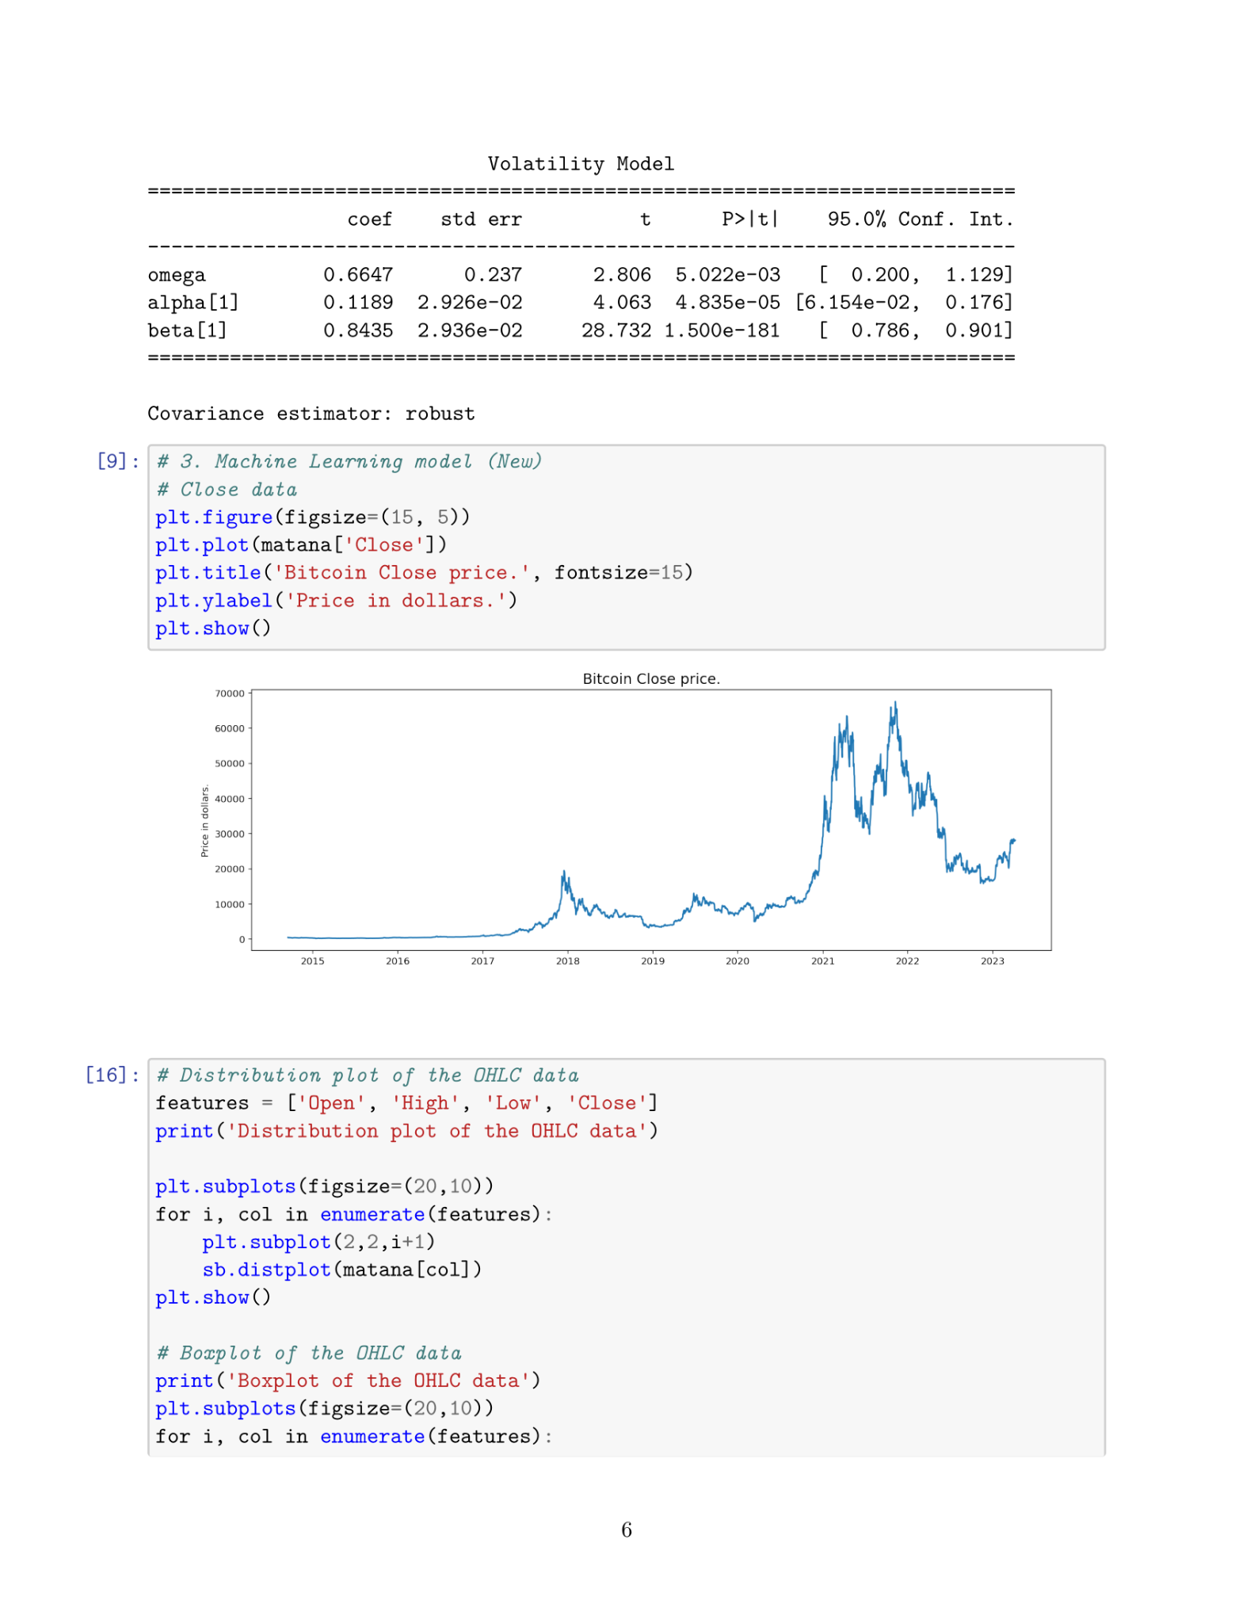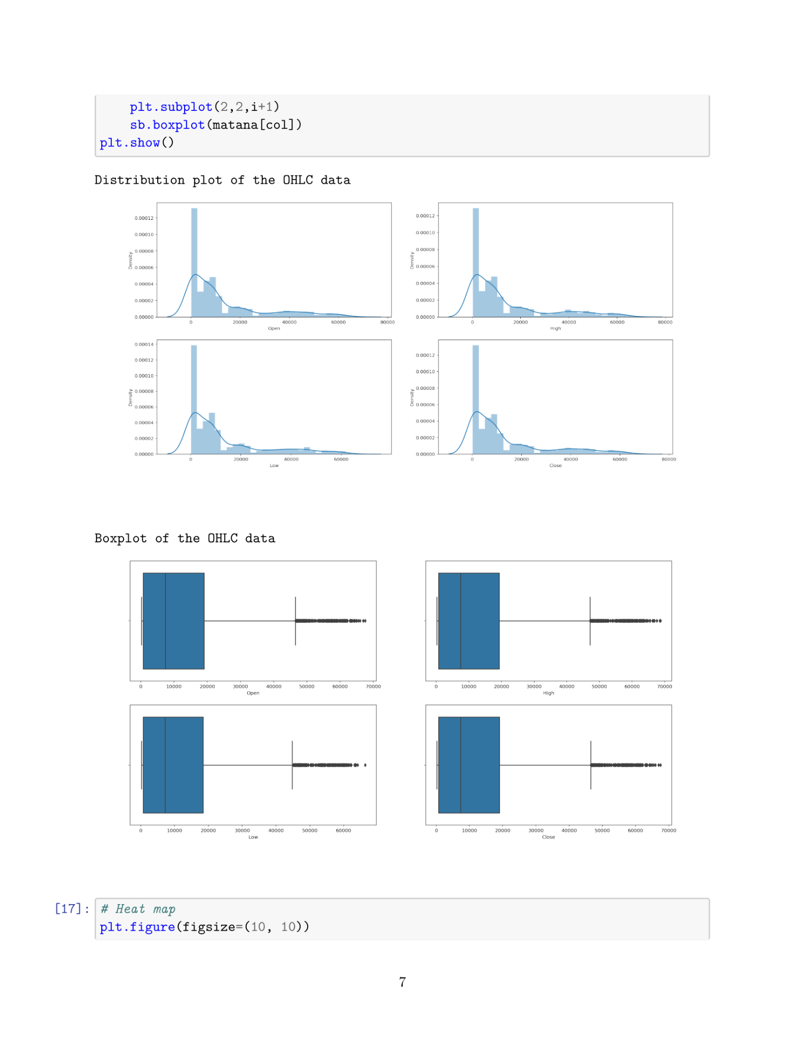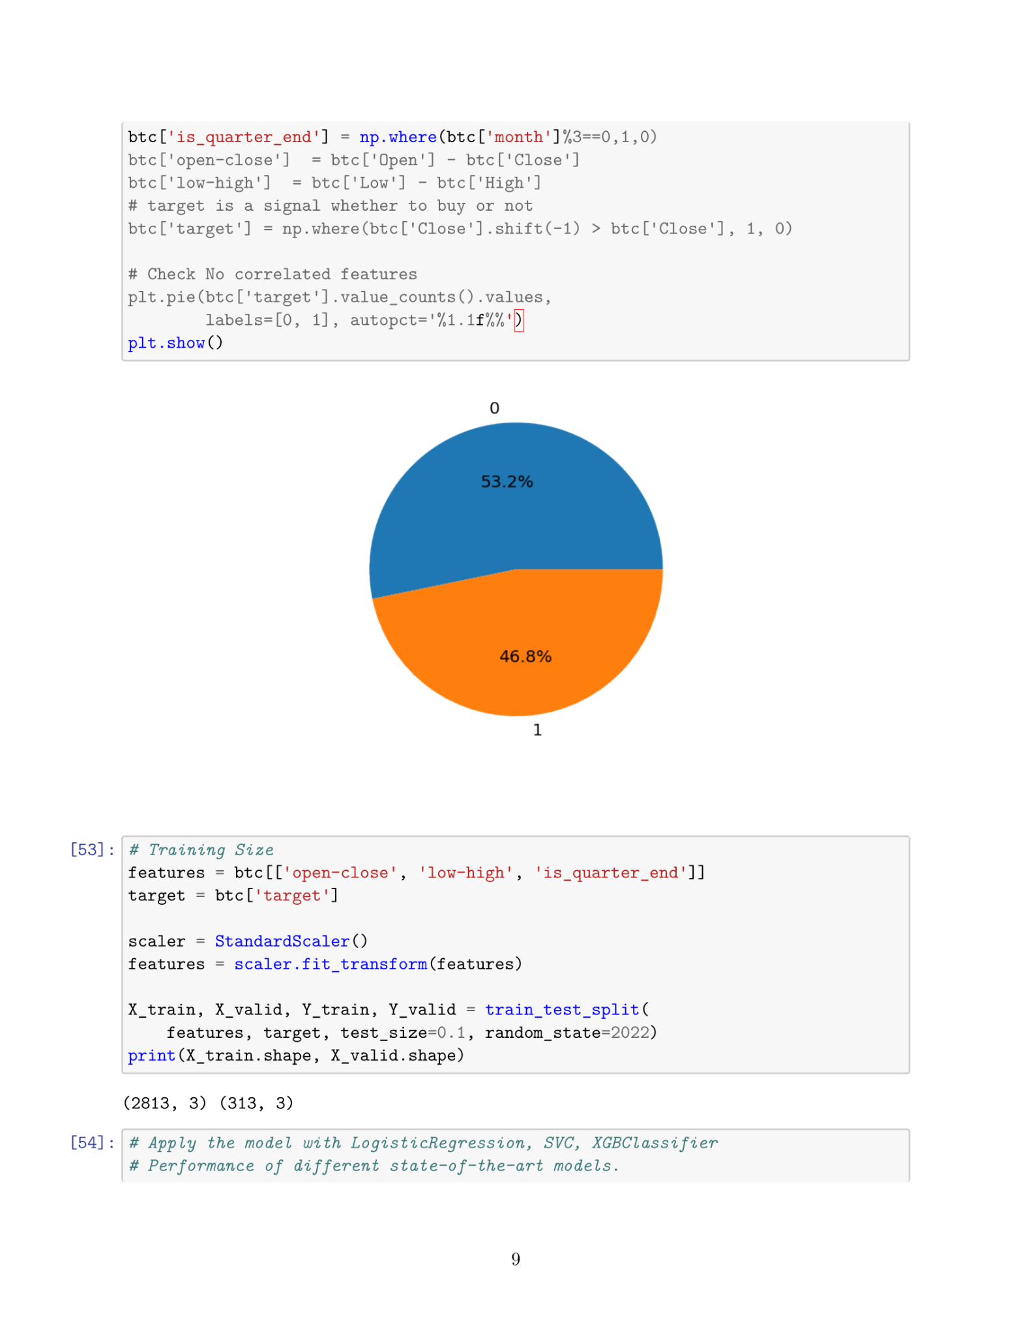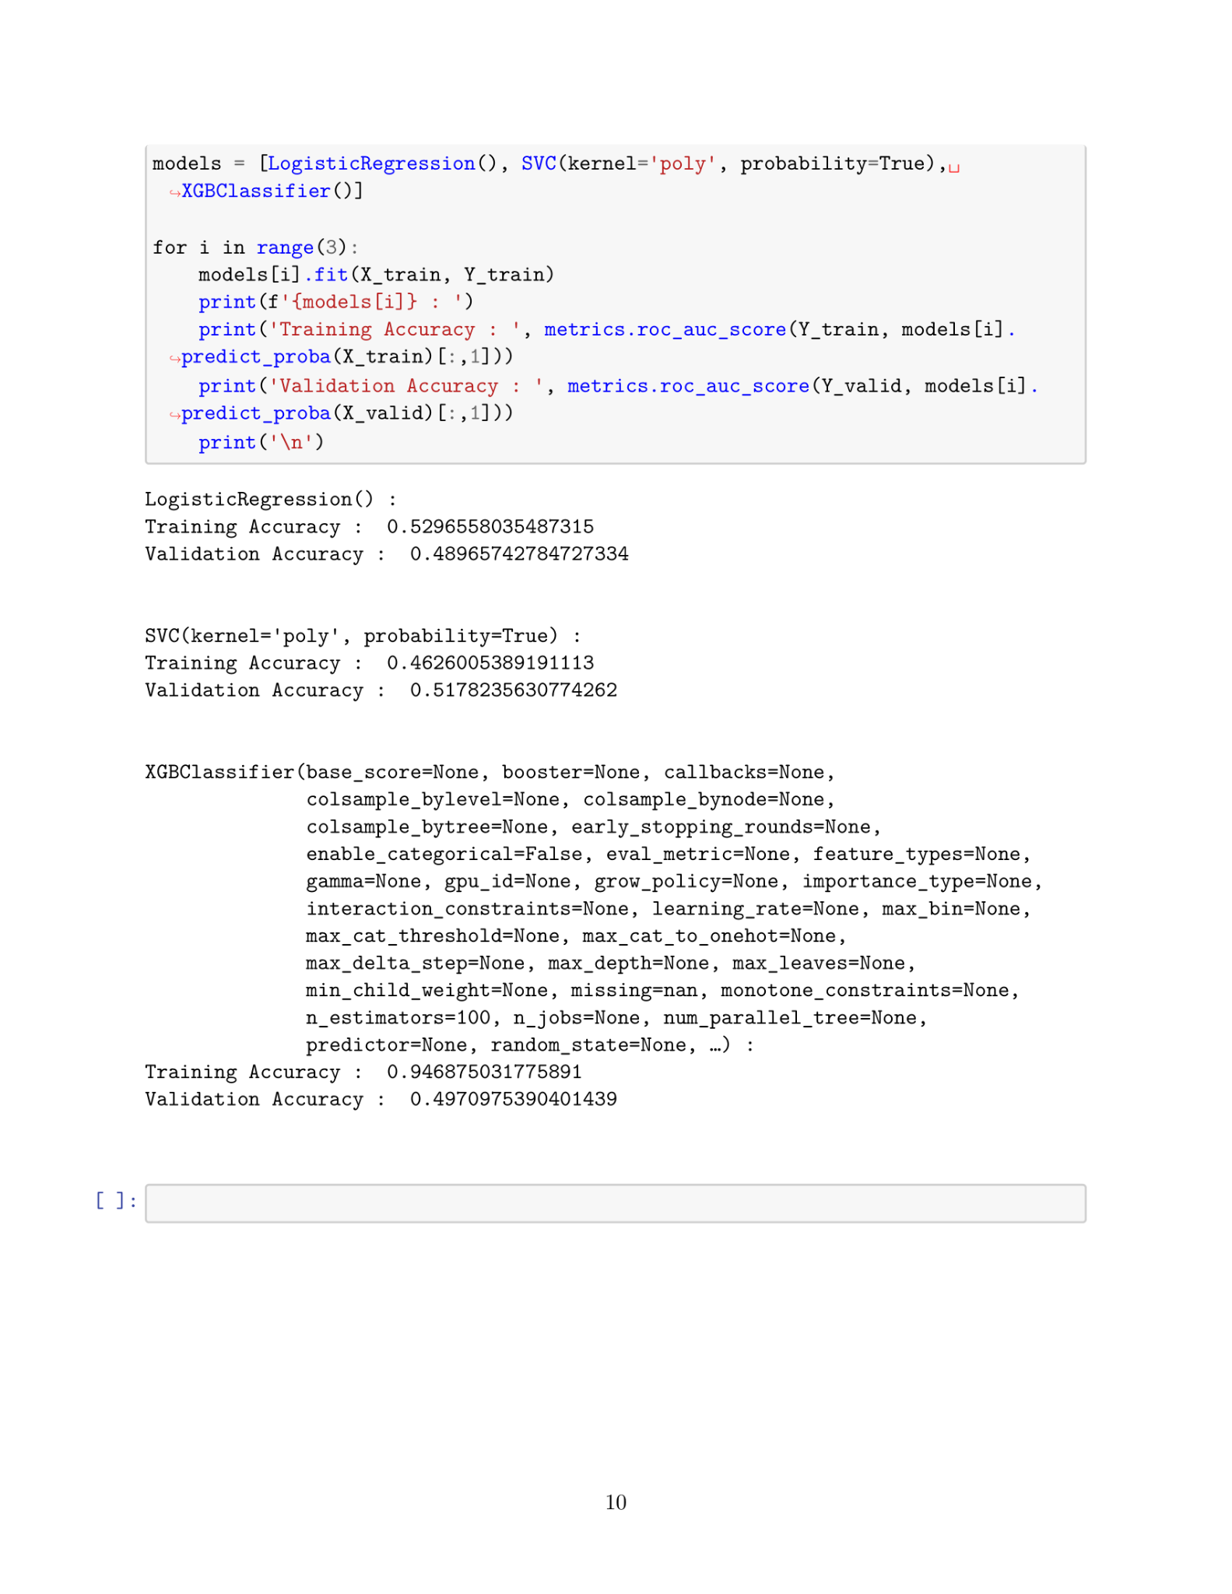

**(c) Portfolio Trading Strategy:**

